Ministry of Education and Science

Federal State Budgetary Educational Institution of Higher Professional Education
St. Petersburg State Mining University

САНКТ-ПЕТЕРБУРГСКИЙ
ГОРНЫЙ УНИВЕРСИТЕТ
NEWSLETTER

Dear colleagues!

We are happy to invite you to participate in the International Forum - Contest ‘Topical Issues of Rational Use of Natural Resources’ which will be held at the St. Petersburg State Mining University on April 25-27, 2012.

Working sections of the Conference:
Section 1. Geology
Section 2. Topical issues in prospecting and development of oil and gas deposits
Section 3. Topical issues in mining of ore and nonmetallic minerals
Section 4. Geodesy, geomechanics and underground construction
Section 5. Mining electromechanics and mining equipment
Section 6. Metallurgy. Physical and chemical regularities of technological processes Section 7. Economics and management
Section 8. Environmental protection
Section 9. Nanotechnologies. IT

Working languages of the Conference are Russian and English.

To participate in the Forum you need to send an application to the Organizing Committee. The deadline for application is March 01, 2012. In case of late application the Organizing Committee does not guarantee preparation of the official letter of invitation necessary to receive the Russian entry visa.
Papers submitted on time will be published. The deadline for paper submission is March 01, 2012.
Layout of the paper: volume – up to 4 pages; font type - Times New Roman, font size - 12 normal, line spacing – 1.5; A4 composition size.
The paper has to be preceded with the surname, first name, second name (patronymics) of the author(s) and full title of the educational institution.
PowerPoint presentations for translation in working sections are to be submitted to the Organizing Committee by e-mail not later than April 01, 2012.

Address of the St. Petersburg State Mining University: 2, 21st Line, St. Petersburg, 199106 Russia

GSM phone: +7 904 649-41-78
Fax: +7 (812) 328-82-48
E-mail: kir.fedorov@gmail.com
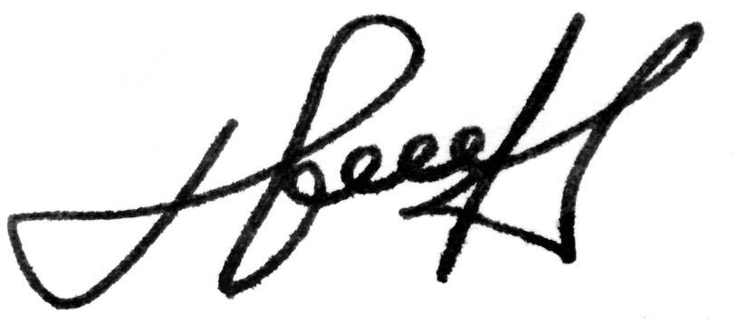

RECTOR, Professor
Vladimir S. Litvinenko

